EWMA correlation: GBPUSD and USDCHF
Method 06 / daily log returns / lambda = 0.94 / Alpari D1 full available history

Study setup
Logical pair: GBPUSD , USDCHF
Broker symbols: GBPUSD_i , USDCHF_i
Snapshot: 2026-11-03_majors_alpari_D1
Timeframe: D1
Matched return window: 1999-01-05 to 2026-11-02 (UTC bar dates)
Matched return count n: 7201
Dropped unfinished last bar dated 2026-11-03 UTC after a tick-volume check against the prior complete day.
Lambda: 0.94 (today weight 0.06)
Burn-in ignored in path summaries and chart: first 60 updates
Mean adjustment: each leg demeaned by its mean on the matched rows
Seeds: c_0 = v_x,0 = v_y,0 = 0
Complete matched rows (Excel): GBPUSD-USDCHF_EWMA_D1.xlsx
Complete matched rows (HTML table): GBPUSD-USDCHF_EWMA_D1_data.html

Method carried forward
EWMA correlation updates covariance and variances of mean-adjusted daily log returns of close, ln(close_t / close_t-1), with lambda = 0.94 (6% weight on today's product or square, 94% on yesterday's EWMA state). Quotes are not inverted. Each leg is demeaned by its mean on the matched rows; that mean uses the full sample, so the rho path is a full-sample description, not a live filter. Seeds start at zero. Path summaries and the chart ignore the first 60 updates so the zero seed has faded. The headline is rho on the last day. rho is symmetric under swap of the two symbols. A high |rho| does not prove cause, lead-lag, or a trading signal. Today's return sits inside today's rho, so the estimate can only inform a later decision. Same-sample Pearson r is a side check only.

Results
Latest EWMA rho: -0.651428
Post-burn-in path (n=7141): mean=-0.562215, median=-0.594491, min=-0.946074, max=0.259116, std=0.200536
Share of post-burn-in days with |rho| >= 0.4: 80.09%; |rho| >= 0.7: 27.63%
Same-sample Pearson r: -0.486083
Latest rho minus r: -0.165345

Conclusion
Over 7201 matched daily log-return rows for GBPUSD and USDCHF (broker quote directions unchanged), latest EWMA rho with lambda=0.94 is -0.6514 (negative, moderate recent linear link in this sample). After a 60-day burn-in, path mean is -0.5622, std is 0.2005, and the range is [-0.9461, 0.2591]. Same-sample Pearson r is -0.4861 (latest rho minus r = -0.1653). This does not establish cause, lead-lag, or a lasting trading rule.

Charts
Daily closes

Daily log returns
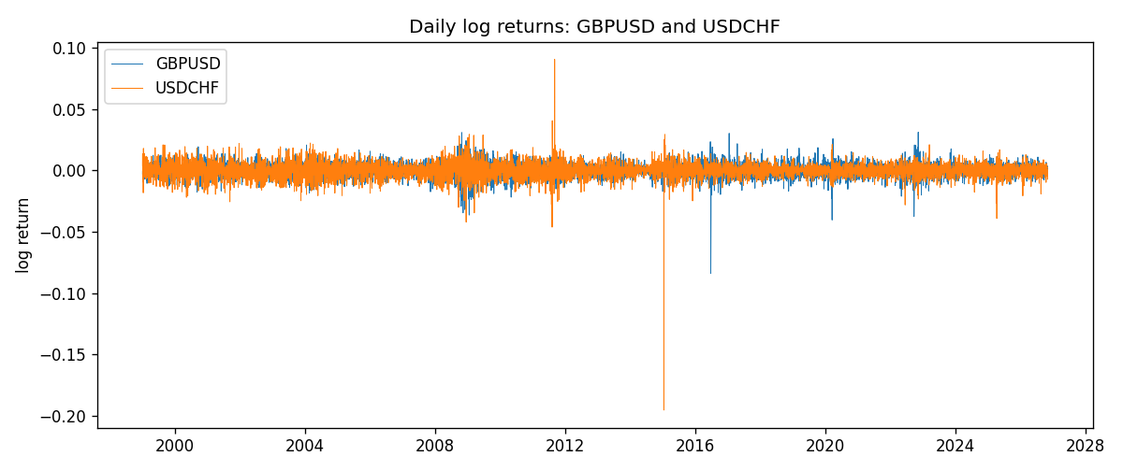
EWMA rho path with Pearson r reference
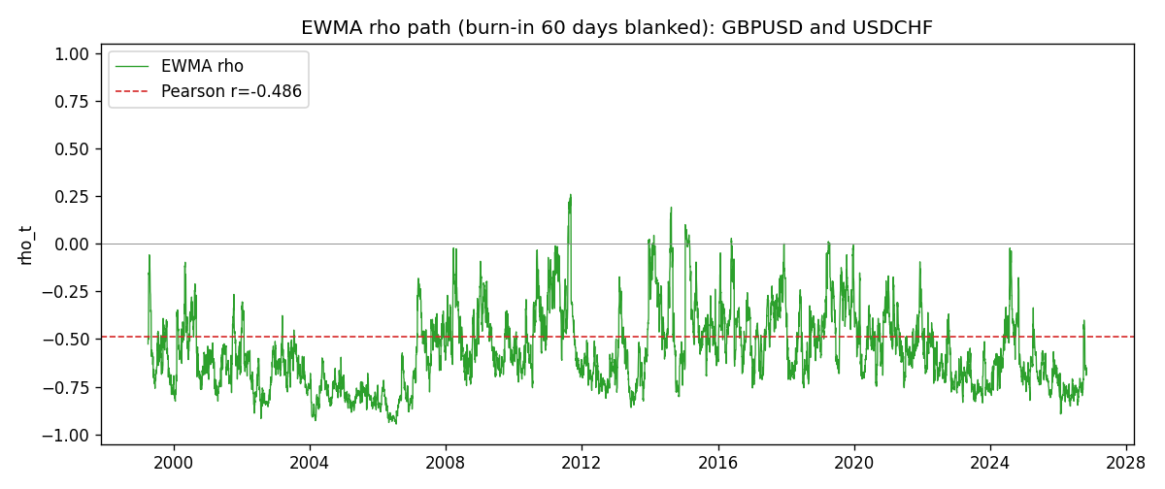

Data report
Every matched row that entered the EWMA recursion is stored in the sibling Excel workbook named GBPUSD-USDCHF_EWMA_D1.xlsx. That file is the complete data archive for redrawing charts. Embedding all rows as a Word table is impractical at this length; the Word file holds the column list, column summaries, and the first and last 15 matched rows.
Columns: time, GBPUSD_open, USDCHF_open, GBPUSD_high, USDCHF_high, GBPUSD_low, USDCHF_low, GBPUSD_close, USDCHF_close, GBPUSD_tick_volume, USDCHF_tick_volume, GBPUSD_spread, USDCHF_spread, GBPUSD_real_volume, USDCHF_real_volume, GBPUSD_log_return, USDCHF_log_return, GBPUSD_x_demeaned, USDCHF_y_demeaned, c_t, v_x, v_y, rho_t
Column summaries (matched calculation rows)
column | count | mean | std | min | 25% | 50% | 75% | max
GBPUSD_open | 7201 | 1.5160785 | 0.218271 | 1.06854 | 1.32499 | 1.51142 | 1.63167 | 2.1066
USDCHF_open | 7201 | 1.0982956 | 0.25264095 | 0.72022 | 0.92069 | 0.99019 | 1.2387 | 1.8219
GBPUSD_high | 7201 | 1.5223771 | 0.21884011 | 1.08366 | 1.32979 | 1.5182 | 1.6384 | 2.1161
USDCHF_high | 7201 | 1.1035944 | 0.25438893 | 0.73305 | 0.92495 | 0.99377 | 1.2436 | 1.8313
GBPUSD_low | 7201 | 1.5097512 | 0.21749696 | 1.03518 | 1.31949 | 1.50336 | 1.6244 | 2.0983
USDCHF_low | 7201 | 1.0931703 | 0.25105533 | 0.08565 | 0.91742 | 0.9867 | 1.2331 | 1.8121
GBPUSD_close | 7201 | 1.5161456 | 0.2182303 | 1.06879 | 1.3251 | 1.5114 | 1.63212 | 2.1065
USDCHF_close | 7201 | 1.0982864 | 0.25254184 | 0.72025 | 0.92098 | 0.9902 | 1.2387 | 1.8217
GBPUSD_tick_volume | 7201 | 94828.085 | 153546.21 | 62 | 10002 | 52900 | 91806 | 1273370
USDCHF_tick_volume | 7201 | 74189.26 | 113409.95 | 18 | 12770 | 40195 | 70240 | 858589
GBPUSD_spread | 7201 | 26.971115 | 19.193539 | 0 | 11 | 20 | 50 | 50
USDCHF_spread | 7201 | 26.114567 | 24.723753 | 0 | 5 | 16 | 50 | 100
GBPUSD_real_volume | 7201 | 3.5560898e+09 | 8.4438214e+10 | 0 | 0 | 0 | 0 | 2.4038164e+12
USDCHF_real_volume | 7201 | 2.3236557e+10 | 8.9041498e+10 | 0 | 0 | 0 | 0 | 1.9331921e+12
GBPUSD_log_return | 7201 | -2.316e-05 | 0.00564524 | -0.08388241 | -0.00312969 | 3.242e-05 | 0.00318104 | 0.03112653
USDCHF_log_return | 7201 | -7.148e-05 | 0.00659332 | -0.19545699 | -0.00335964 | 8.06e-05 | 0.00331782 | 0.09051364
GBPUSD_x_demeaned | 7201 | 0 | 0.00564524 | -0.08385925 | -0.00310653 | 5.558e-05 | 0.0032042 | 0.03114969
USDCHF_y_demeaned | 7201 | 0 | 0.00659332 | -0.19538551 | -0.00328817 | 0.00015207 | 0.00338929 | 0.09058512
c_t | 7201 | -1.807e-05 | 1.343e-05 | -0.00011024 | -2.329e-05 | -1.513e-05 | -9.45e-06 | 2.441e-05
v_x | 7201 | 3.184e-05 | 3.403e-05 | 4.9e-07 | 1.749e-05 | 2.391e-05 | 3.339e-05 | 0.00052545
v_y | 7201 | 4.343e-05 | 9.012e-05 | 9.7e-07 | 1.841e-05 | 2.971e-05 | 4.757e-05 | 0.00231278
rho_t | 7201 | -0.56241597 | 0.20016607 | -1 | -0.71269463 | -0.5941127 | -0.4446761 | 0.25911599
First 15 matched rows (selected columns)
time | GBPUSD_close | USDCHF_close | GBPUSD_log_return | USDCHF_log_return | GBPUSD_x_demeaned | USDCHF_y_demeaned | c_t | v_x | v_y | rho_t
1999-01-05 | 1.6547 | 1.3724 | -0.0028966287 | 0.0039424743 | -0.0028734671 | 0.0040139498 | -6.9203717e-07 | 4.9540879e-07 | 9.6670759e-07 | -1
1999-01-06 | 1.6537 | 1.3912 | -0.00060452184 | 0.013605652 | -0.00058136029 | 0.013677128 | -1.1275953e-06 | 4.8596305e-07 | 1.2132534e-05 | -0.46438251
1999-01-07 | 1.6502 | 1.3782 | -0.002118709 | -0.0093883841 | -0.0020955474 | -0.0093169086 | 1.1150188e-07 | 7.2028441e-07 | 1.6612869e-05 | 0.032233528
1999-01-08 | 1.6405 | 1.3935 | -0.0058954193 | 0.011040268 | -0.0058722577 | 0.011111744 | -3.8102495e-06 | 2.746072e-06 | 2.3024348e-05 | -0.47918564
1999-01-11 | 1.6312 | 1.4009 | -0.0056851331 | 0.0052963193 | -0.0056619716 | 0.0053677948 | -5.4051727e-06 | 4.504783e-06 | 2.337168e-05 | -0.52677805
1999-01-12 | 1.6349 | 1.3872 | 0.0022657001 | -0.0098275602 | 0.0022888617 | -0.0097560846 | -6.420682e-06 | 4.5488293e-06 | 2.7680251e-05 | -0.572198
1999-01-13 | 1.6499 | 1.3621 | 0.0091330396 | -0.018259701 | 0.0091562012 | -0.018188225 | -1.6027544e-05 | 9.3060607e-06 | 4.5868127e-05 | -0.77576205
1999-01-14 | 1.6531 | 1.3588 | 0.0019376331 | -0.0024256692 | 0.0019607946 | -0.0023541936 | -1.5342857e-05 | 8.97838e-06 | 4.3448573e-05 | -0.77681835
1999-01-15 | 1.6502 | 1.3834 | -0.0017558204 | 0.01794228 | -0.0017326588 | 0.018013755 | -1.6294987e-05 | 8.6198036e-06 | 6.0311382e-05 | -0.71467022
1999-01-18 | 1.6522 | 1.379 | 0.0012112405 | -0.0031856384 | 0.001234402 | -0.0031141628 | -1.5547935e-05 | 8.1940403e-06 | 5.727458e-05 | -0.71769963
1999-01-19 | 1.6553 | 1.3789 | 0.0018745281 | -7.2518946e-05 | 0.0018976897 | -1.0433801e-06 | -1.4615178e-05 | 7.9184714e-06 | 5.3838105e-05 | -0.70784562
1999-01-20 | 1.6472 | 1.3889 | -0.0049053846 | 0.0072259871 | -0.004882223 | 0.0072974626 | -1.5875938e-05 | 8.8735292e-06 | 5.3802996e-05 | -0.72658757
1999-01-21 | 1.6524 | 1.3836 | 0.0031518998 | -0.0038232689 | 0.0031750614 | -0.0037517933 | -1.5638112e-05 | 8.9459784e-06 | 5.1419374e-05 | -0.72913342
1999-01-22 | 1.6565 | 1.3834 | 0.0024781662 | -0.0001445609 | 0.0025013278 | -7.3085331e-05 | -1.4710794e-05 | 8.7846181e-06 | 4.8334532e-05 | -0.71391401
1999-01-25 | 1.6585 | 1.3868 | 0.0012066366 | 0.0024546976 | 0.0012297982 | 0.0025261732 | -1.3641745e-05 | 8.3482852e-06 | 4.5817353e-05 | -0.69751941
Last 15 matched rows (selected columns)
time | GBPUSD_close | USDCHF_close | GBPUSD_log_return | USDCHF_log_return | GBPUSD_x_demeaned | USDCHF_y_demeaned | c_t | v_x | v_y | rho_t
2026-10-13 | 1.32534 | 0.83244 | 0.0036434319 | -0.0024955621 | 0.0036665934 | -0.0024240865 | -5.4018101e-06 | 9.4689833e-06 | 1.3296867e-05 | -0.48140764
2026-10-14 | 1.31884 | 0.83489 | -0.0049164679 | 0.0029388325 | -0.0048933064 | 0.003010308 | -5.9615231e-06 | 1.0337511e-05 | 1.3042772e-05 | -0.51340995
2026-10-15 | 1.32757 | 0.82676 | 0.0065976411 | -0.0097855323 | 0.0066208026 | -0.0097140567 | -9.4627228e-06 | 1.2347362e-05 | 1.792198e-05 | -0.63611558
2026-10-16 | 1.33257 | 0.82377 | 0.0037592051 | -0.0036230826 | 0.0037823666 | -0.003551607 | -9.7009683e-06 | 1.2464898e-05 | 1.7603496e-05 | -0.65489437
2026-10-19 | 1.33024 | 0.82677 | -0.0017500314 | 0.0036351779 | -0.0017268699 | 0.0037066535 | -9.5029647e-06 | 1.1895929e-05 | 1.7371643e-05 | -0.66105788
2026-10-20 | 1.3377 | 0.8246 | 0.0055923442 | -0.0026281224 | 0.0056155058 | -0.0025566468 | -9.7941987e-06 | 1.3074208e-05 | 1.6721531e-05 | -0.66240439
2026-10-21 | 1.33937 | 0.82427 | 0.0012476328 | -0.00040027413 | 0.0012707944 | -0.00032879857 | -9.2316169e-06 | 1.238665e-05 | 1.5724726e-05 | -0.6614687
2026-10-22 | 1.33967 | 0.82032 | 0.00022396082 | -0.0048036381 | 0.00024712238 | -0.0047321625 | -8.7478853e-06 | 1.1647115e-05 | 1.6124844e-05 | -0.63833129
2026-10-23 | 1.33684 | 0.82497 | -0.0021146949 | 0.005652514 | -0.0020915334 | 0.0057239896 | -8.9413271e-06 | 1.1210759e-05 | 1.7123197e-05 | -0.64534515
2026-10-26 | 1.33359 | 0.82649 | -0.0024340661 | 0.0018407959 | -0.0024109046 | 0.0019122715 | -8.6814657e-06 | 1.0886861e-05 | 1.6315212e-05 | -0.65139639
2026-10-27 | 1.33044 | 0.82865 | -0.0023648393 | 0.0026100526 | -0.0023416778 | 0.0026815282 | -8.5373342e-06 | 1.0562657e-05 | 1.5767735e-05 | -0.66153229
2026-10-28 | 1.33254 | 0.82781 | 0.0015771808 | -0.0010142111 | 0.0016003423 | -0.00094273555 | -8.1156162e-06 | 1.0082563e-05 | 1.4874996e-05 | -0.6626857
2026-10-29 | 1.33733 | 0.82379 | 0.0035881935 | -0.0048680164 | 0.0036113551 | -0.0047965408 | -8.6679999e-06 | 1.0260123e-05 | 1.5362904e-05 | -0.69040824
2026-10-30 | 1.33913 | 0.82438 | 0.0013450605 | 0.00071594559 | 0.001368222 | 0.00078742116 | -8.0832779e-06 | 9.7568372e-06 | 1.4478332e-05 | -0.68010148
2026-11-02 | 1.3406 | 0.81851 | 0.0010971256 | -0.0071459744 | 0.0011202871 | -0.0070744989 | -8.0738094e-06 | 9.2467295e-06 | 1.6612544e-05 | -0.65142789

